Deployment Documentation: Travel Memory Application
Project Overview
This document details the successful deployment of the MERN-stack TravelMemory application on Amazon Web Services (AWS). The architecture utilizes EC2 instances, Nginx for reverse proxying, PM2 for process management, an Application Load Balancer (ALB) for scaling, and Cloudflare for secure custom domain management.

Deployment Architecture
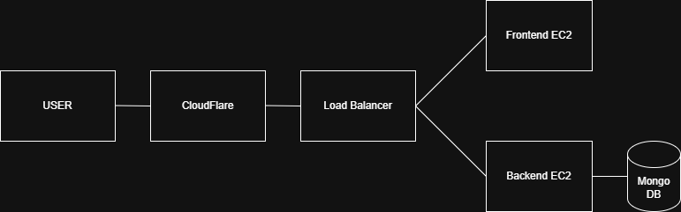

Phase 1: AWS Infrastructure Provisioning
- Configured the Virtual Private Cloud (VPC) to establish an isolated network environment.
- Created and assigned Security Groups to allow inbound traffic for SSH, HTTP, and HTTPS and custom tcp 3000 and 3001 for node and react.
- Provisioned the primary Amazon EC2 instance to serve as the backend host.
- Successfully established a secure SSH connection to the EC2 instance to begin environment configuration.
Screenshot : security group config
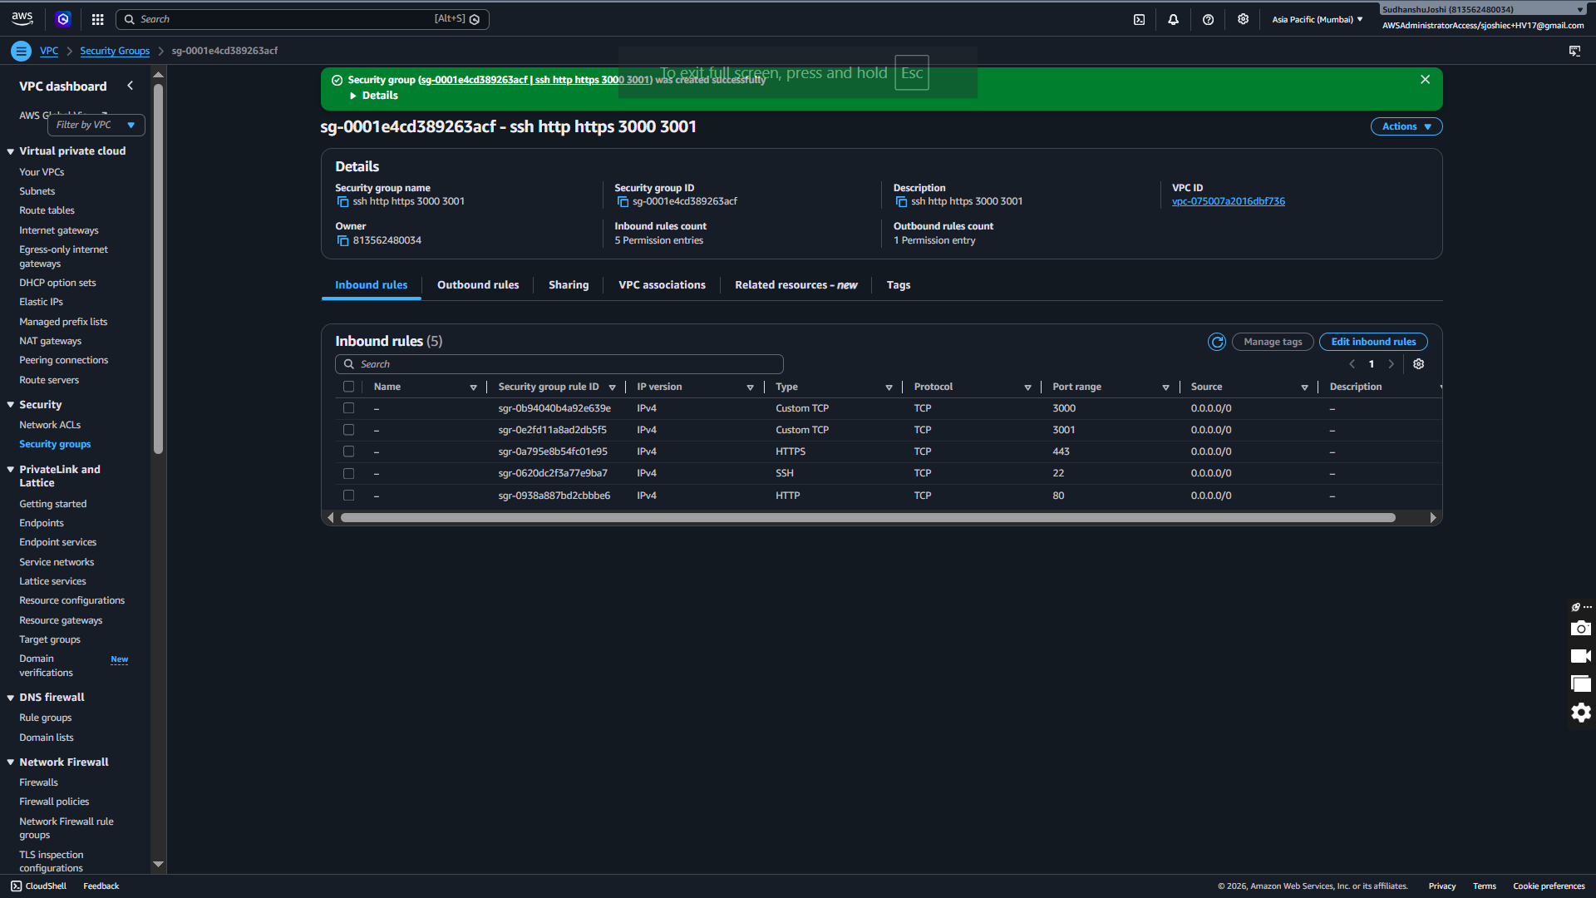

Phase 2: Backend Configuration
- Installed Node.js and npm package manager on the backend EC2 instance.
Screenshot : nodejs npm
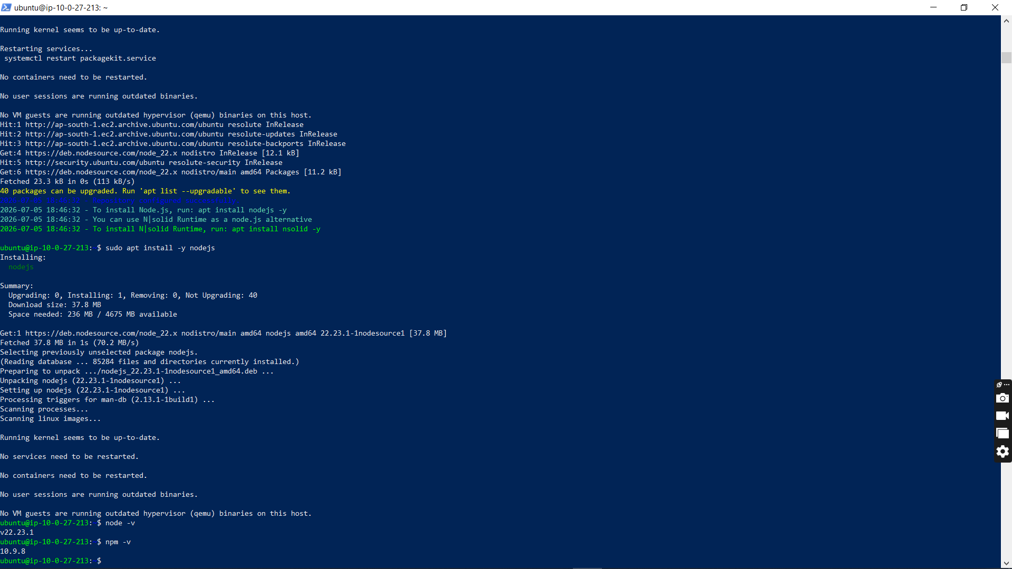
- Cloned the TravelMemory project repository from GitHub into the server.
Screenshot : git clone
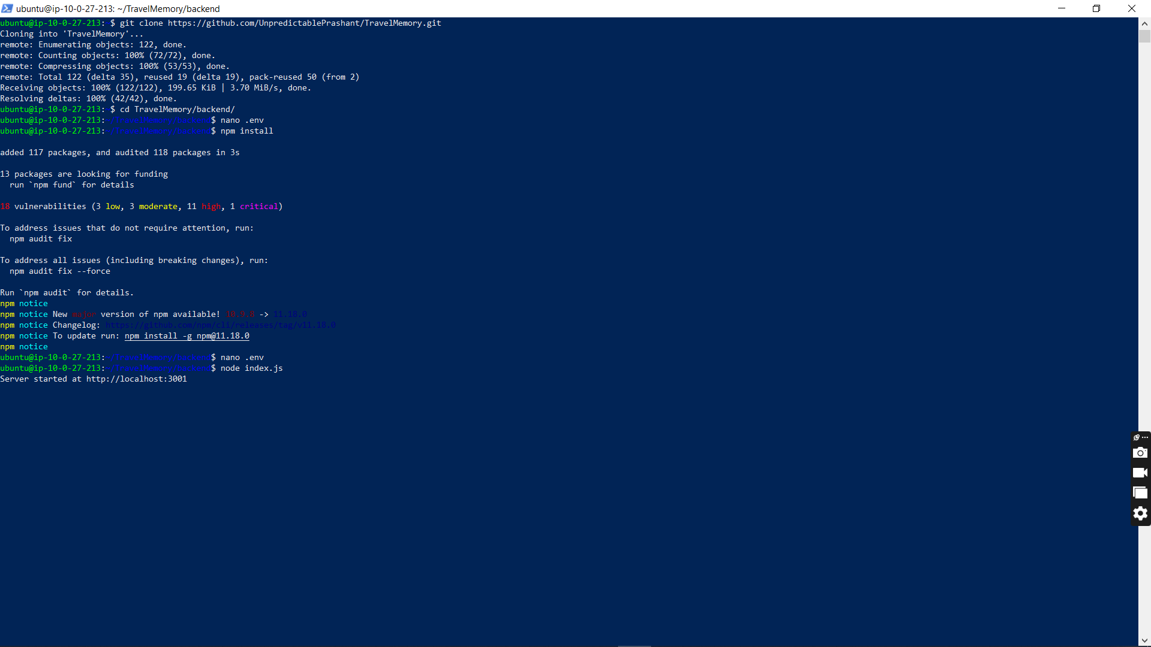
- Created and configured environment (.env) variables, including the application port and MongoDB URI.
Screenshot : mongodb atlus uri
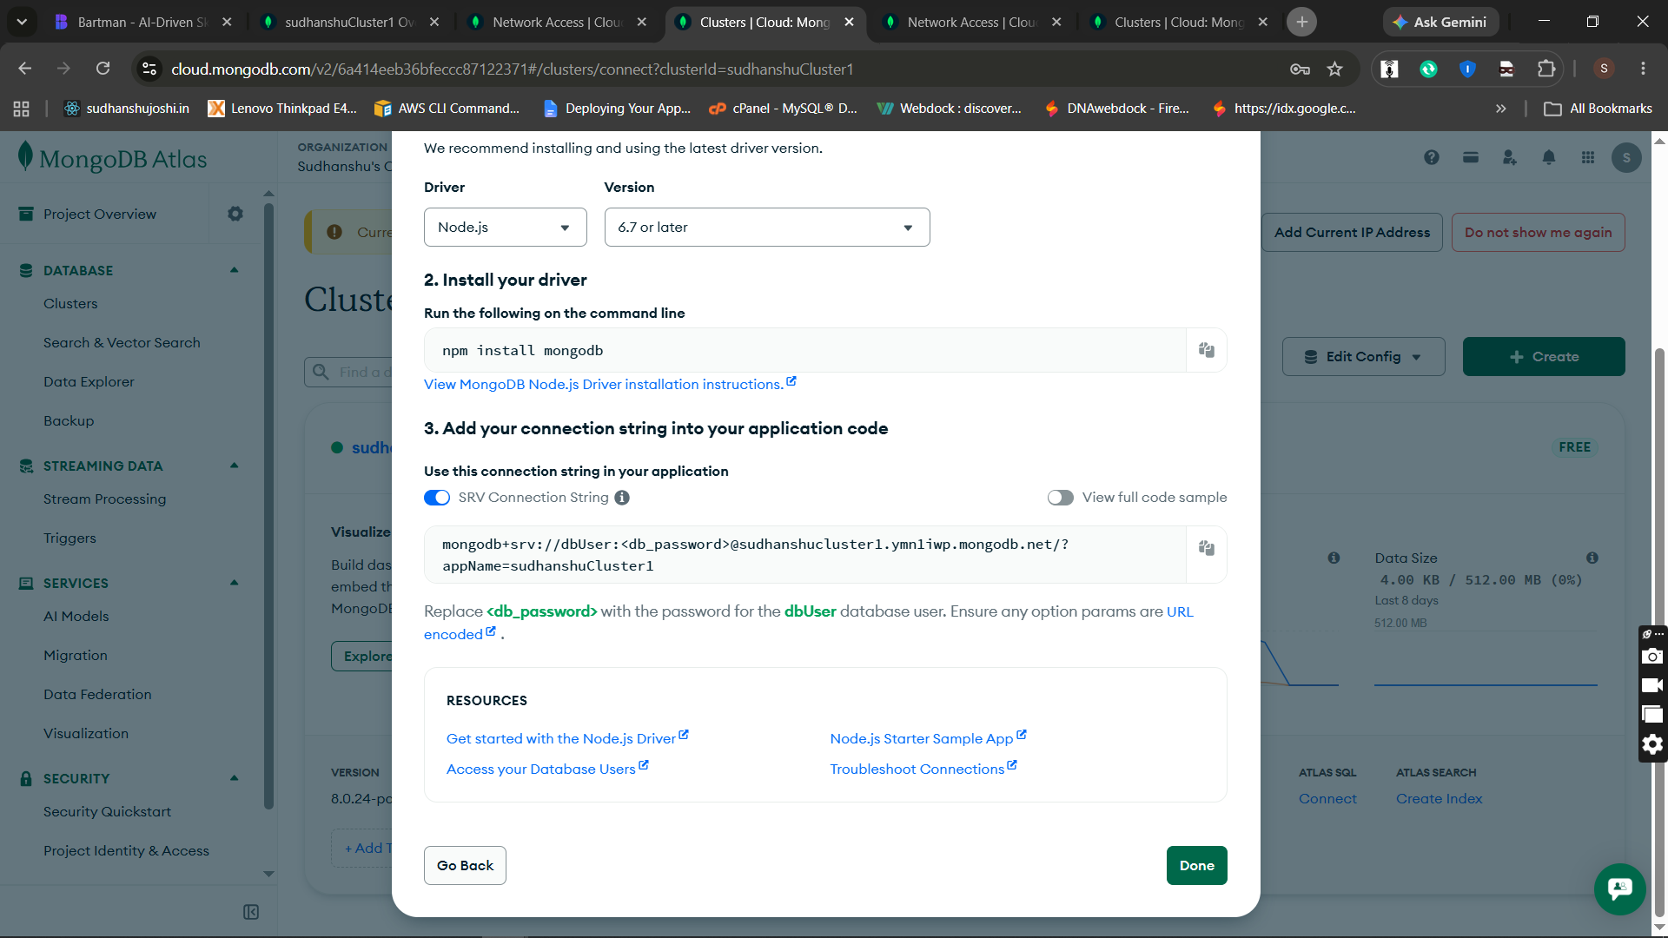
Screenshot : allow all mongo db ip access
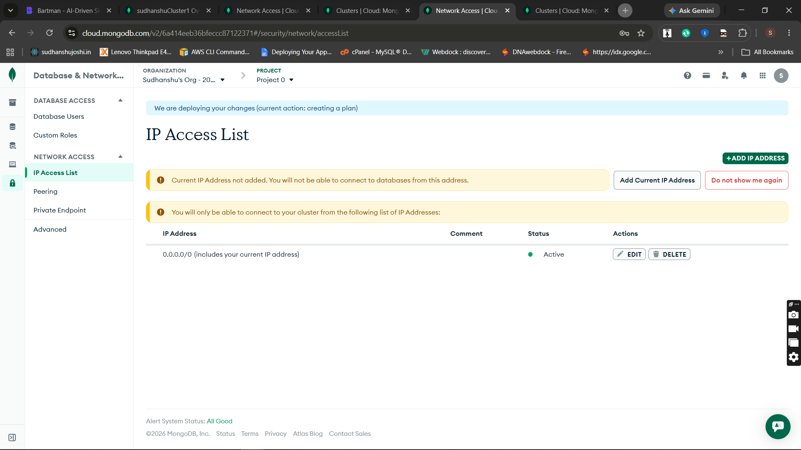
- Successfully connected the backend application to the MongoDB database.
Screenshot : env setup
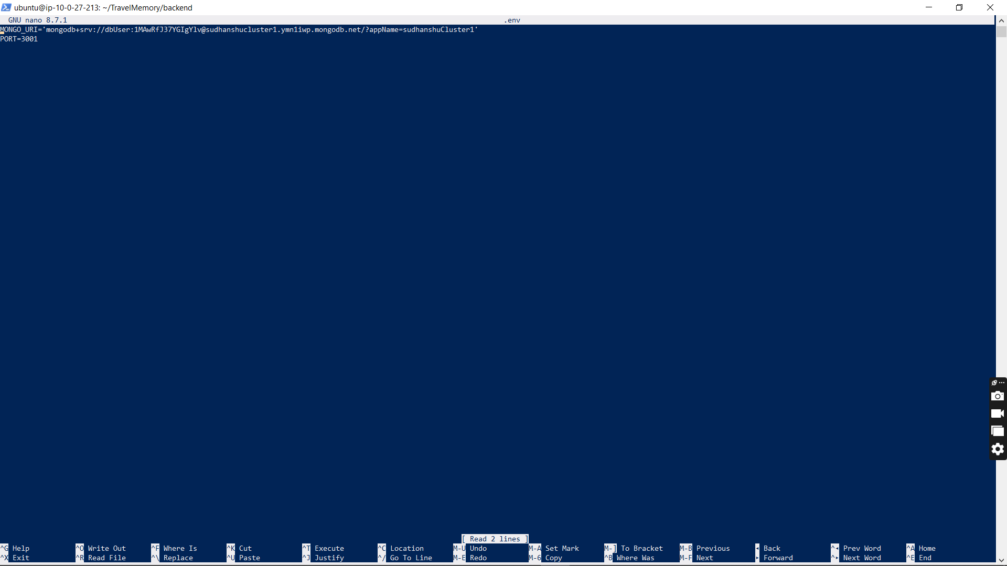
- Installed the PM2 process manager globally using npm.
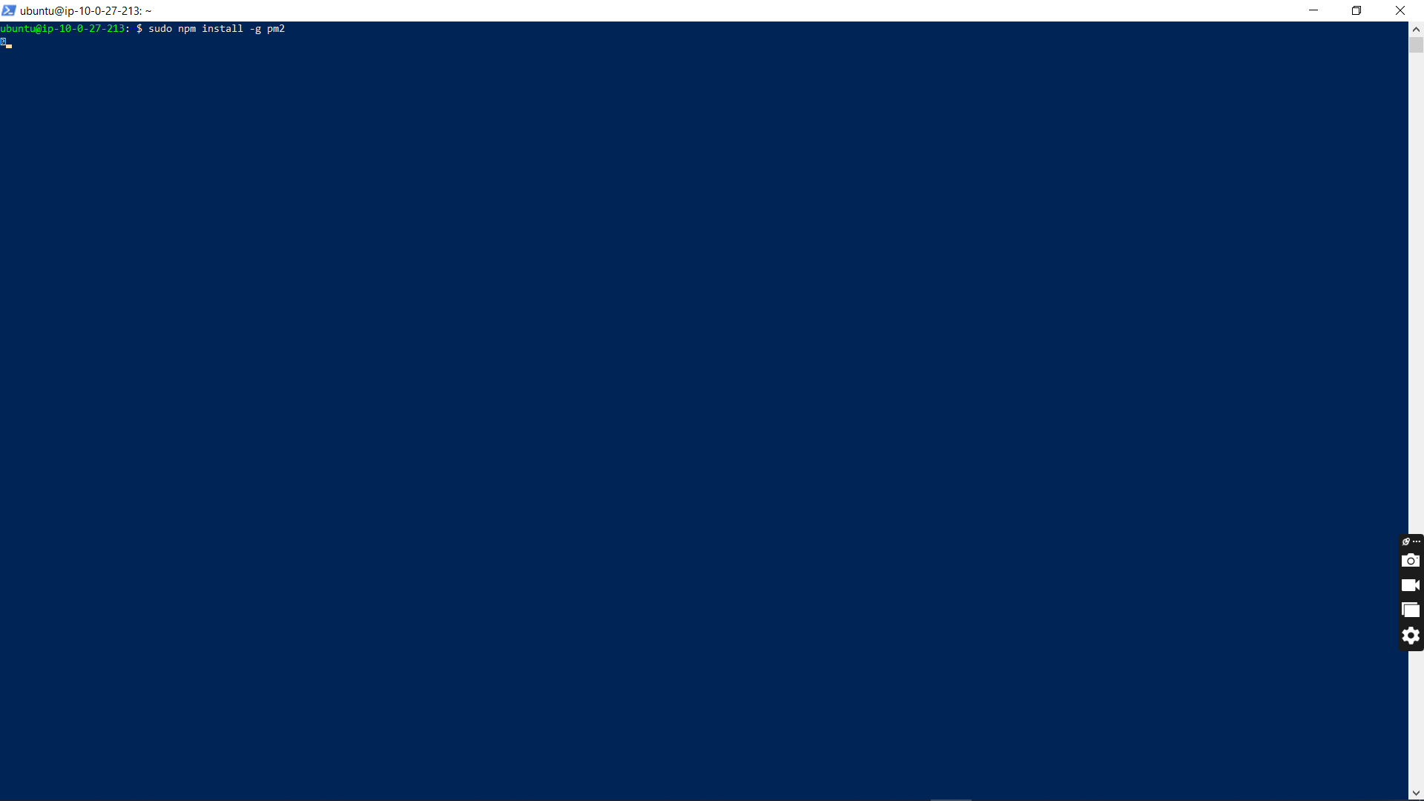
- Started the backend Node.js server using PM2 to ensure continuous background execution.
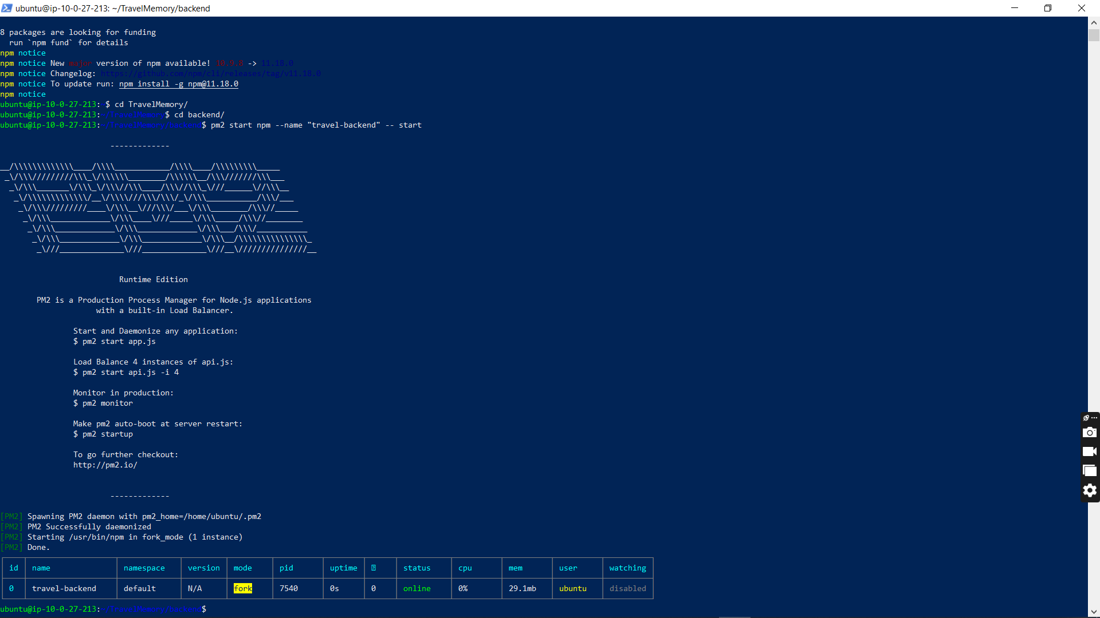
- Verified backend functionality by testing API access directly via the EC2 instance's public IP address.
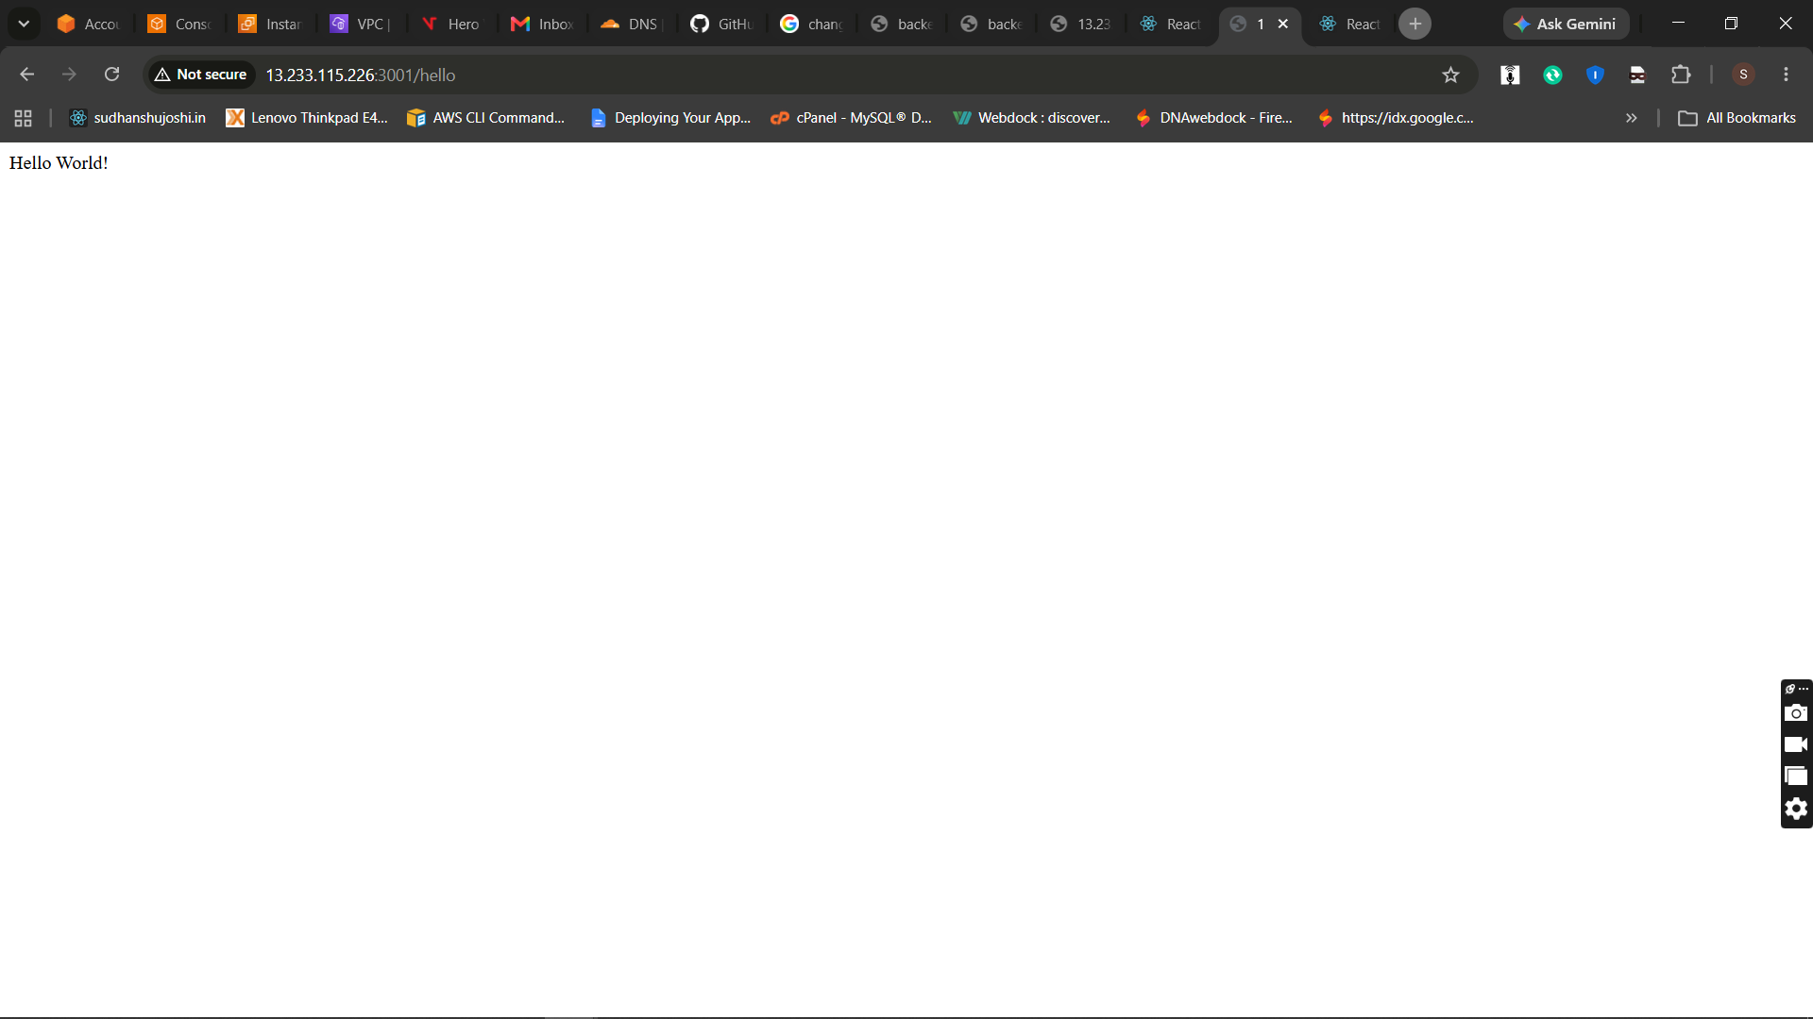

Phase 3: Frontend Configuration
- Provisioned the frontend environment by installing Node.js and cloning the repository.
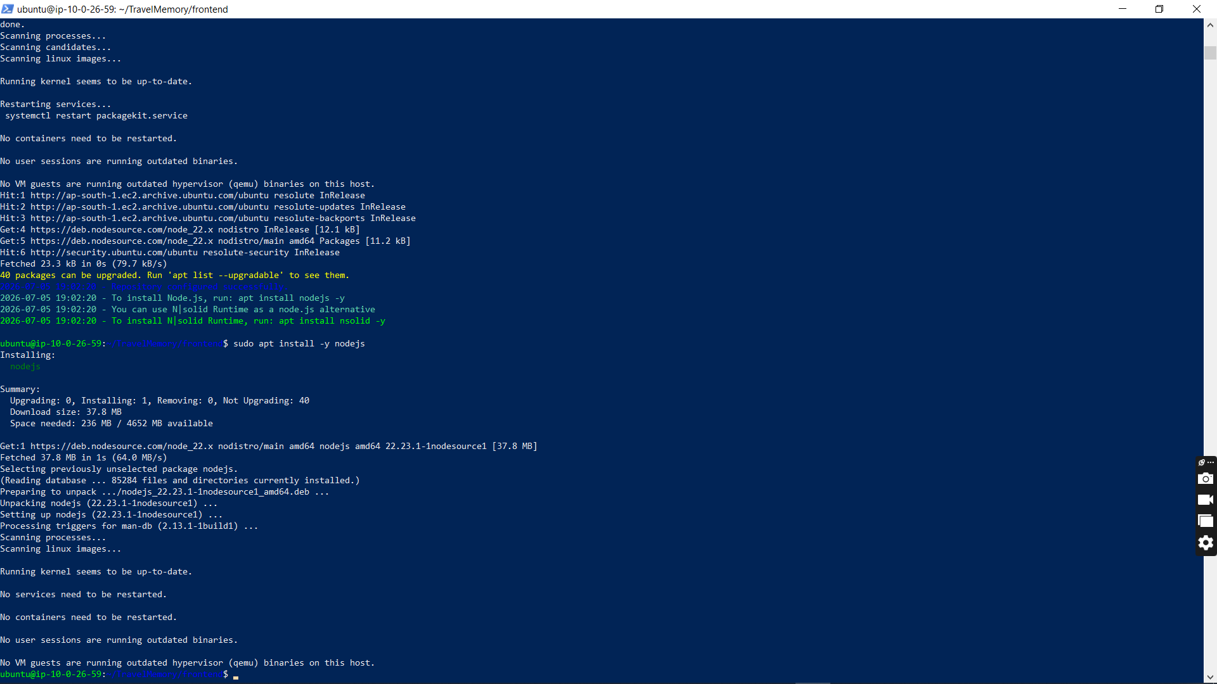
- Updated frontend configuration files to point the base URL to the backend server.
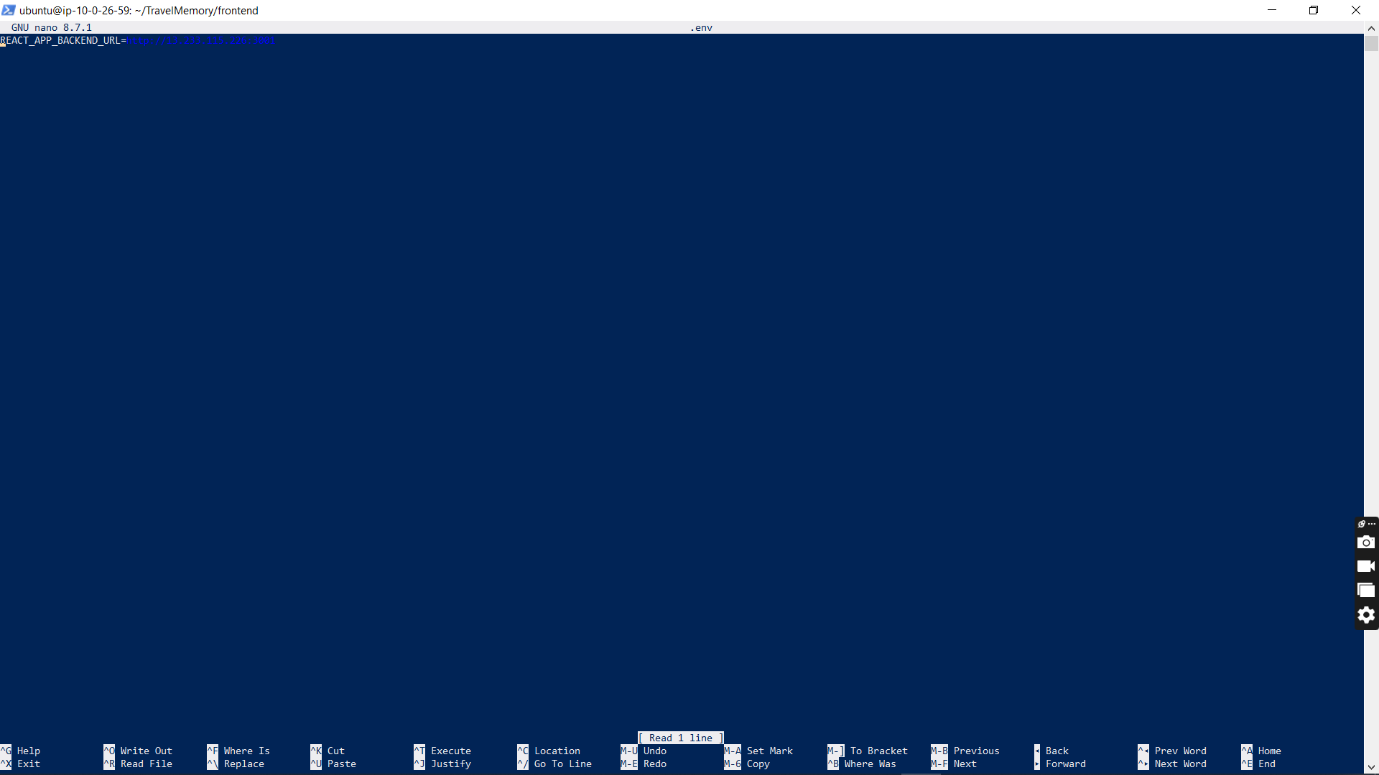
- Tested the frontend application via its IP address and confirmed successful data retrieval from the backend.
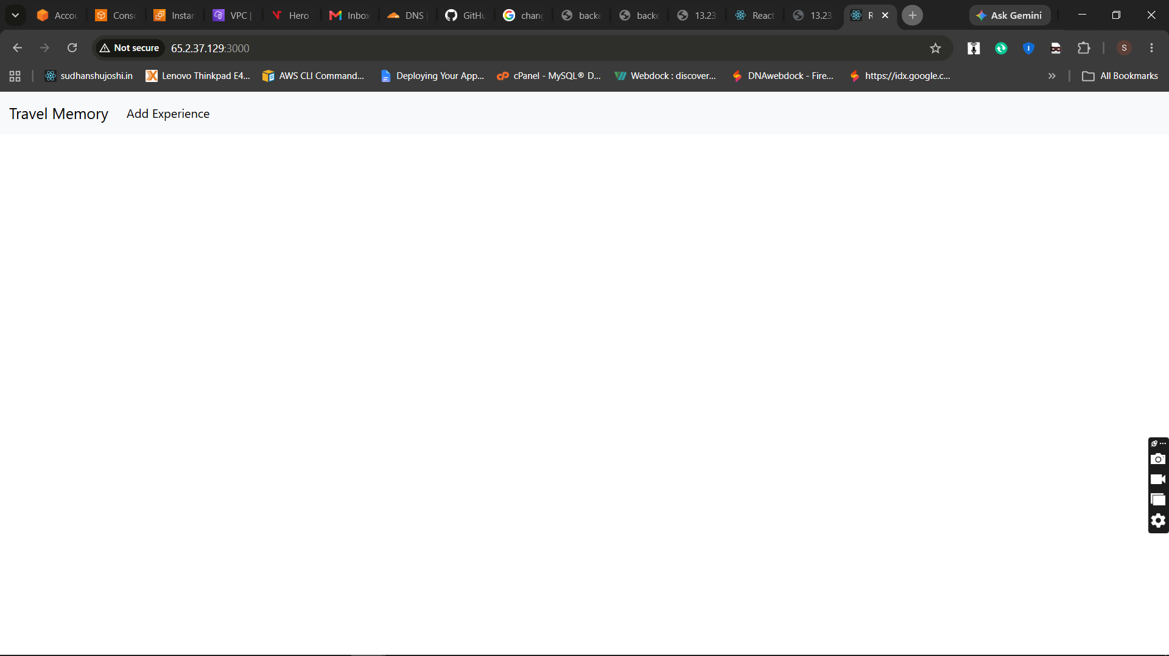

Phase 4: Reverse Proxy Configuration
- Installed Nginx on the EC2 instances to route incoming web traffic.
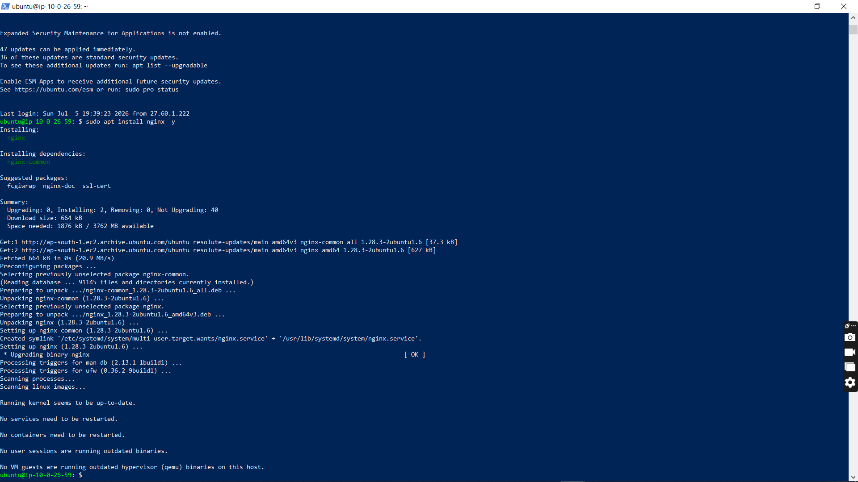
- Configured Nginx as a reverse proxy, forwarding port 80 traffic to internal Node.js and React application ports.
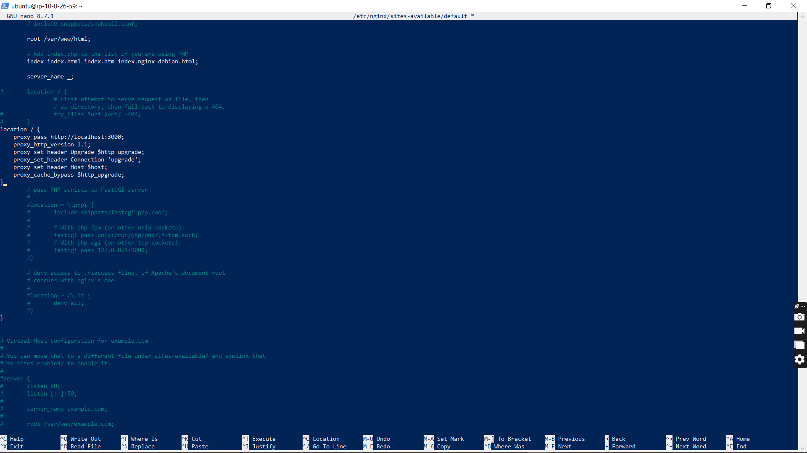
- Successfully tested reverse proxy routing for both frontend and backend applications.
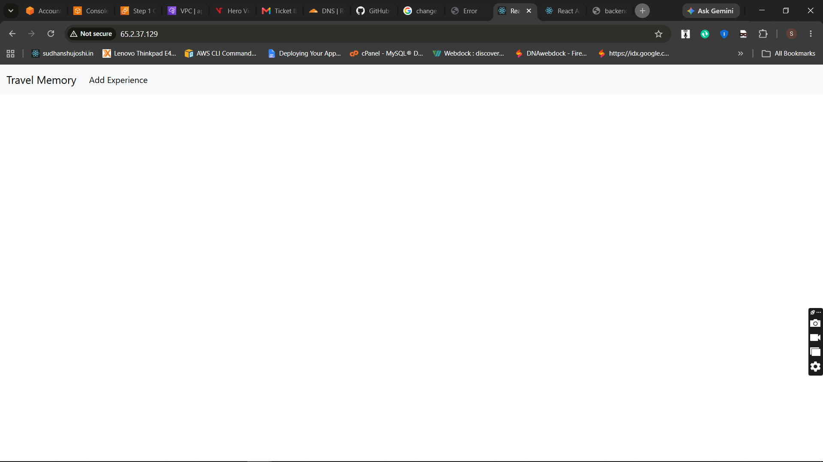
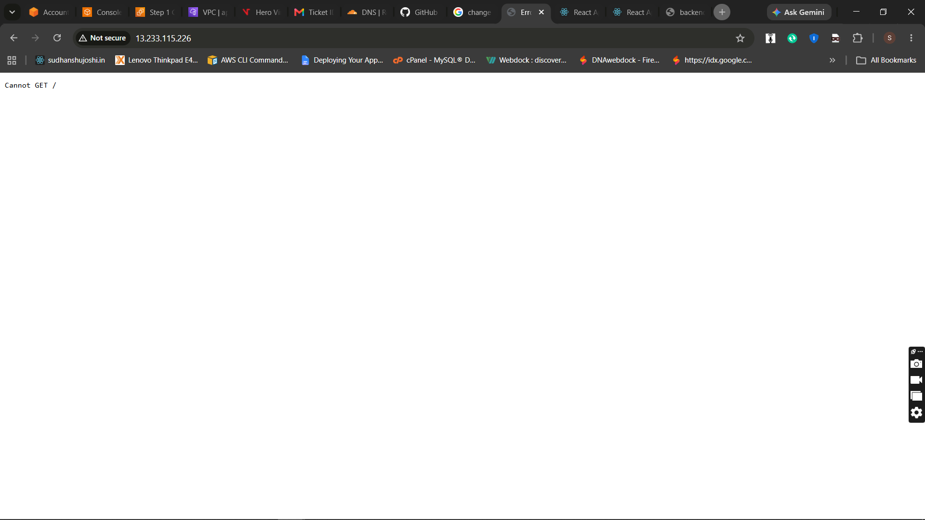

Phase 5: Application Scaling
- Created Amazon Machine Images (AMIs) from the fully configured frontend and backend instances.
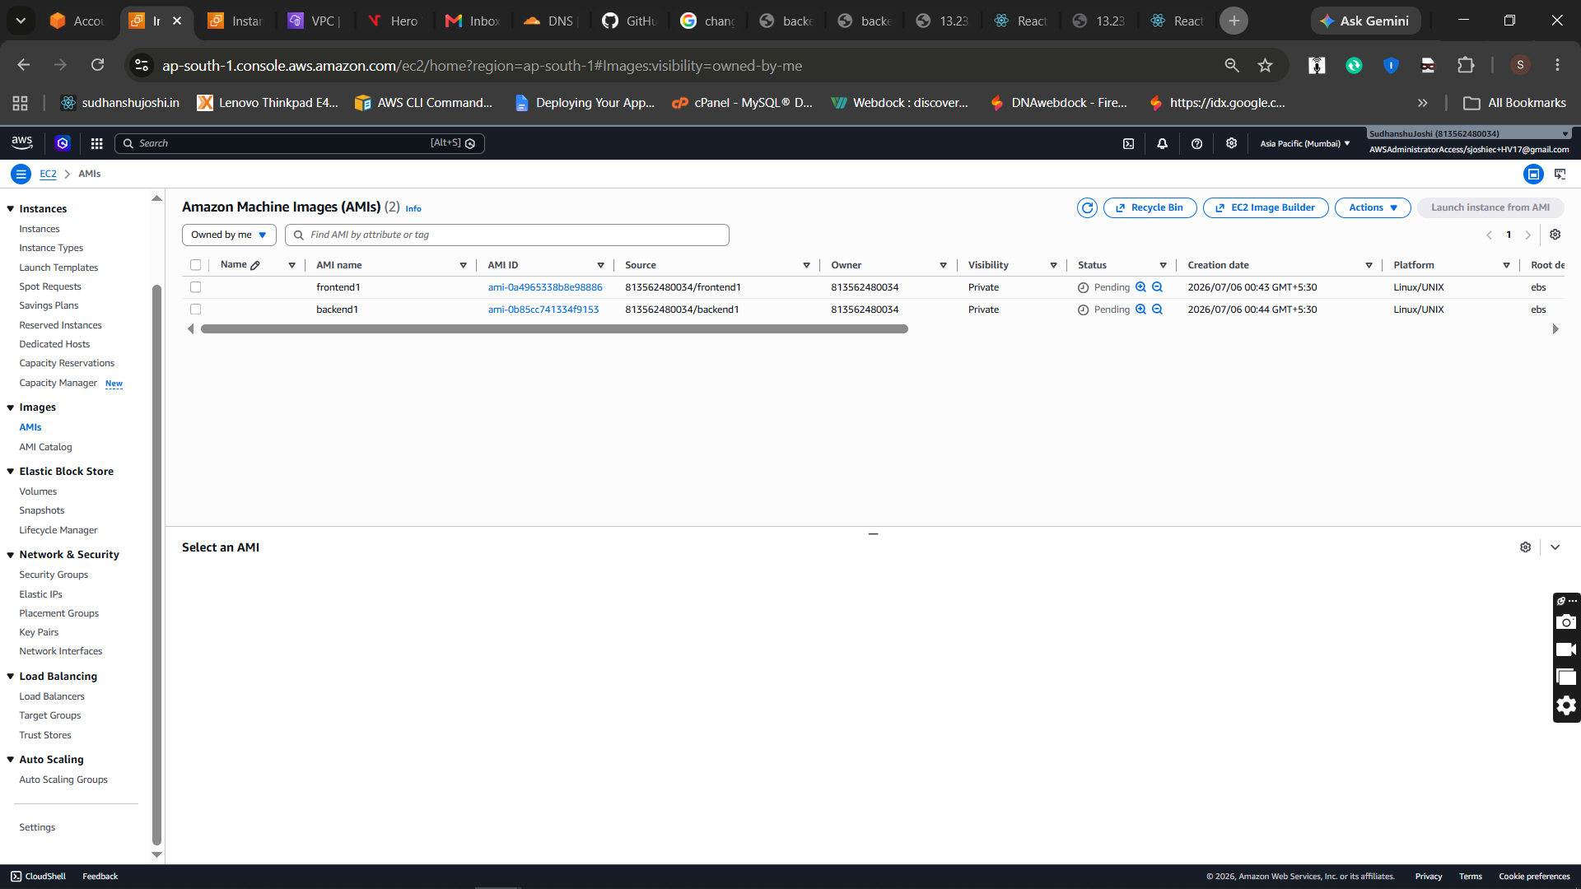
- Launched additional EC2 instances from the custom AMIs to create a scaled multi-node environment.
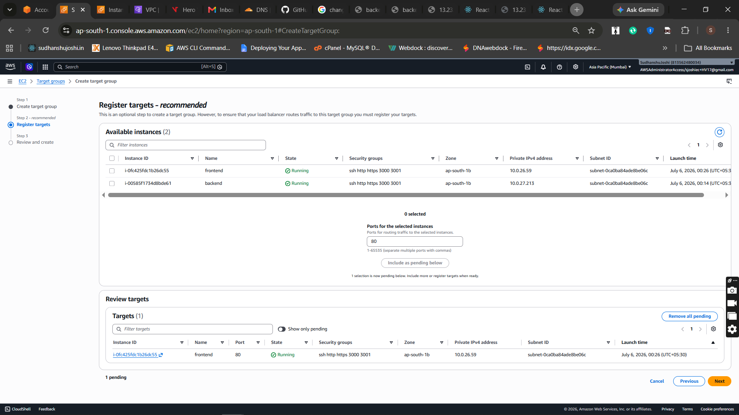
- Provisioned and configured an AWS Application Load Balancer (ALB) to distribute incoming traffic.
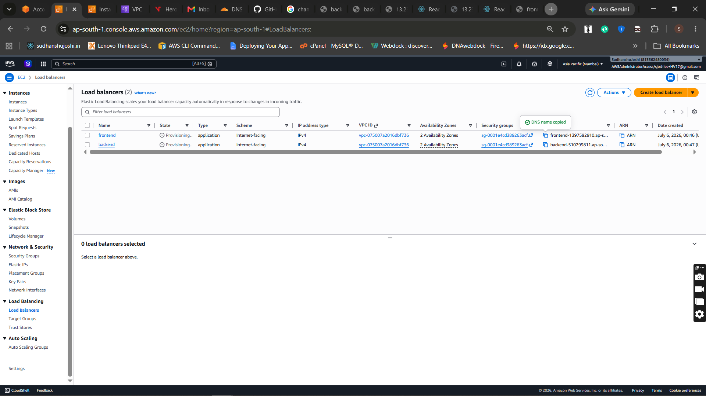
- Successfully tested the Load Balancer endpoint and verified traffic distribution across frontend nodes.
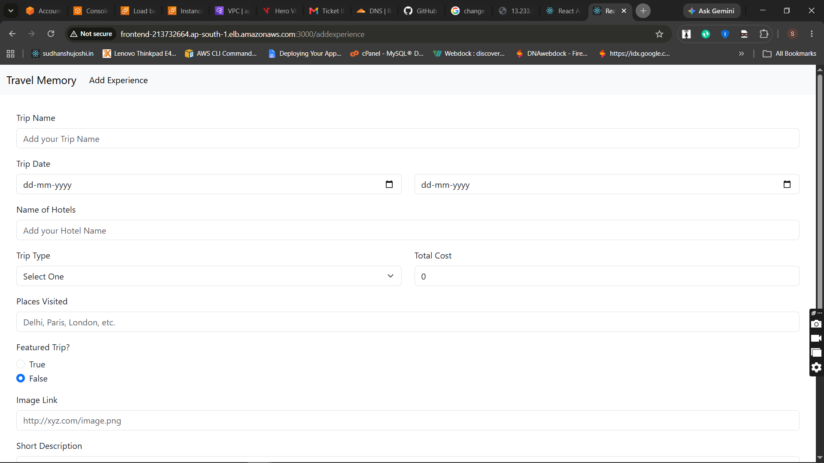

Phase 6: Cloudflare DNS and Custom Domain
- Added the custom domain to Cloudflare and accessed the DNS management console.
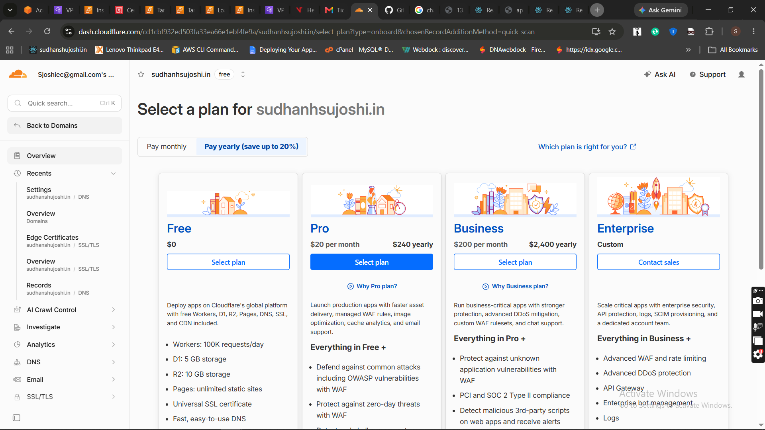
- Created DNS records to route traffic to the AWS infrastructure.
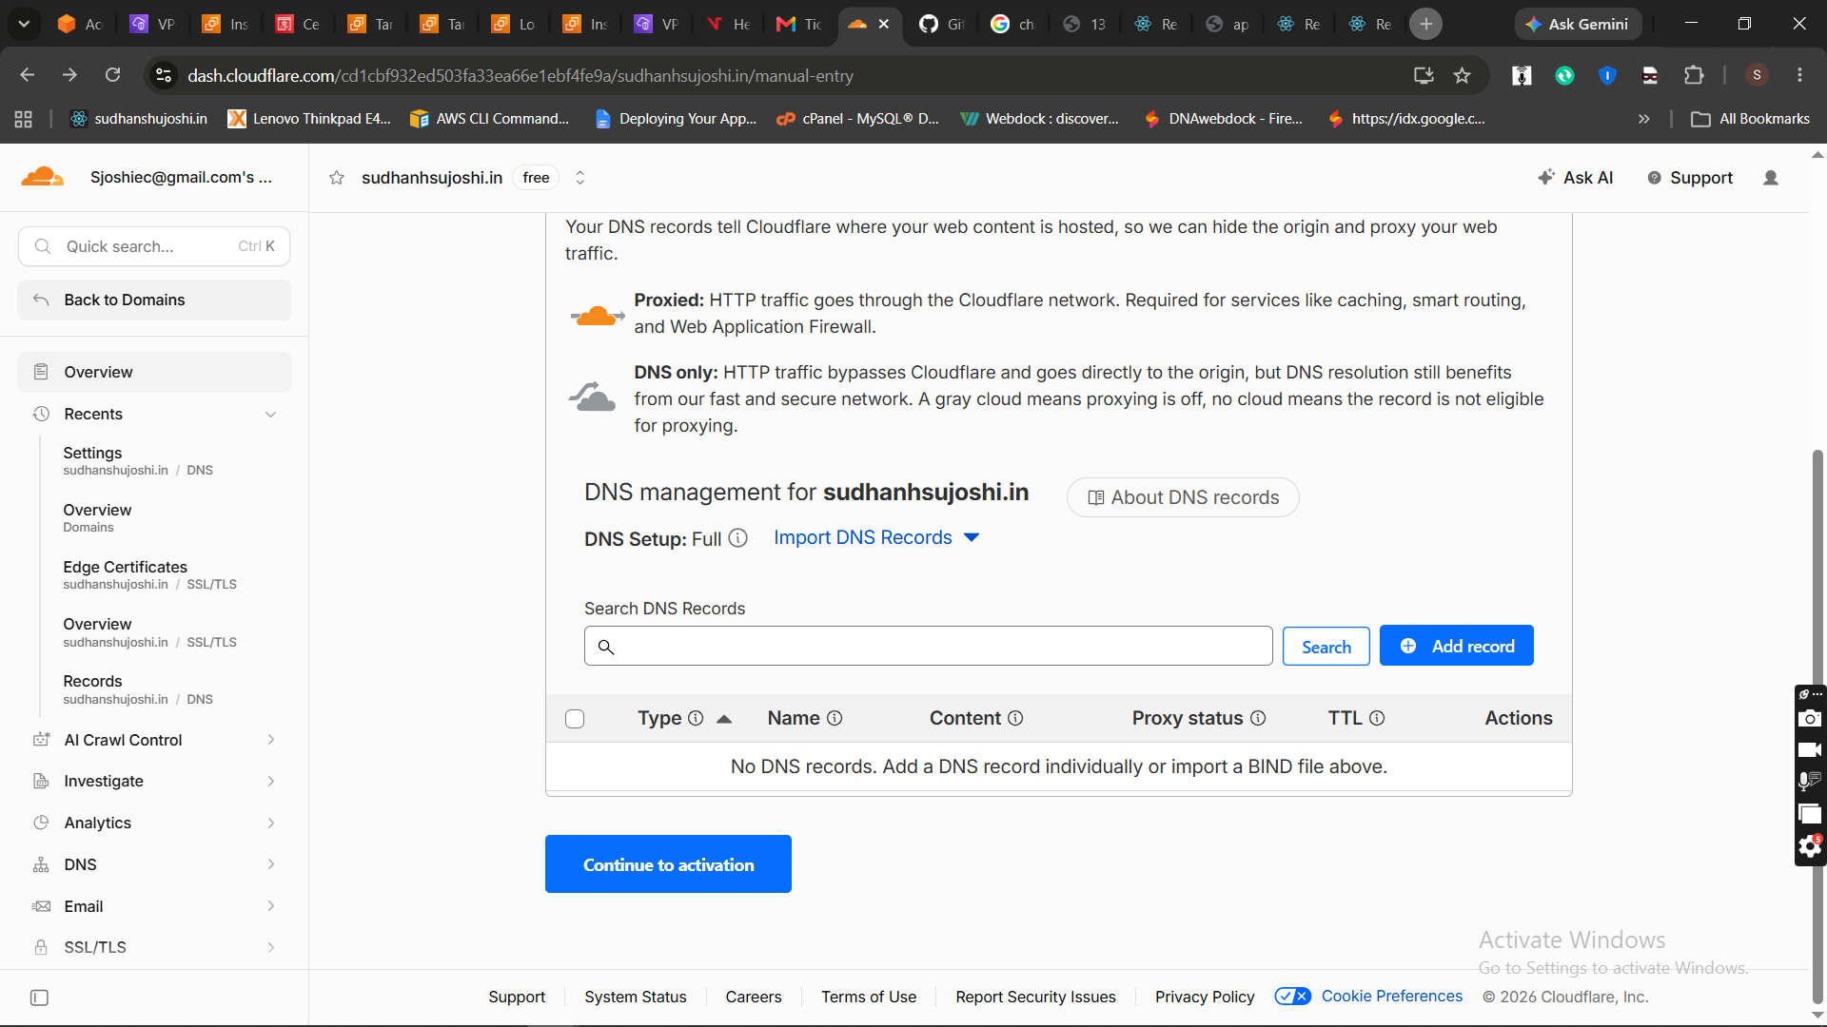
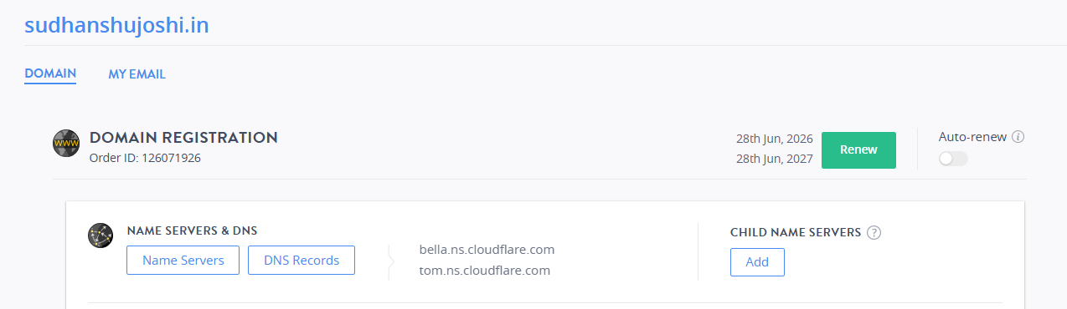
- Configured a CNAME record to route API requests to the backend Load Balancer.
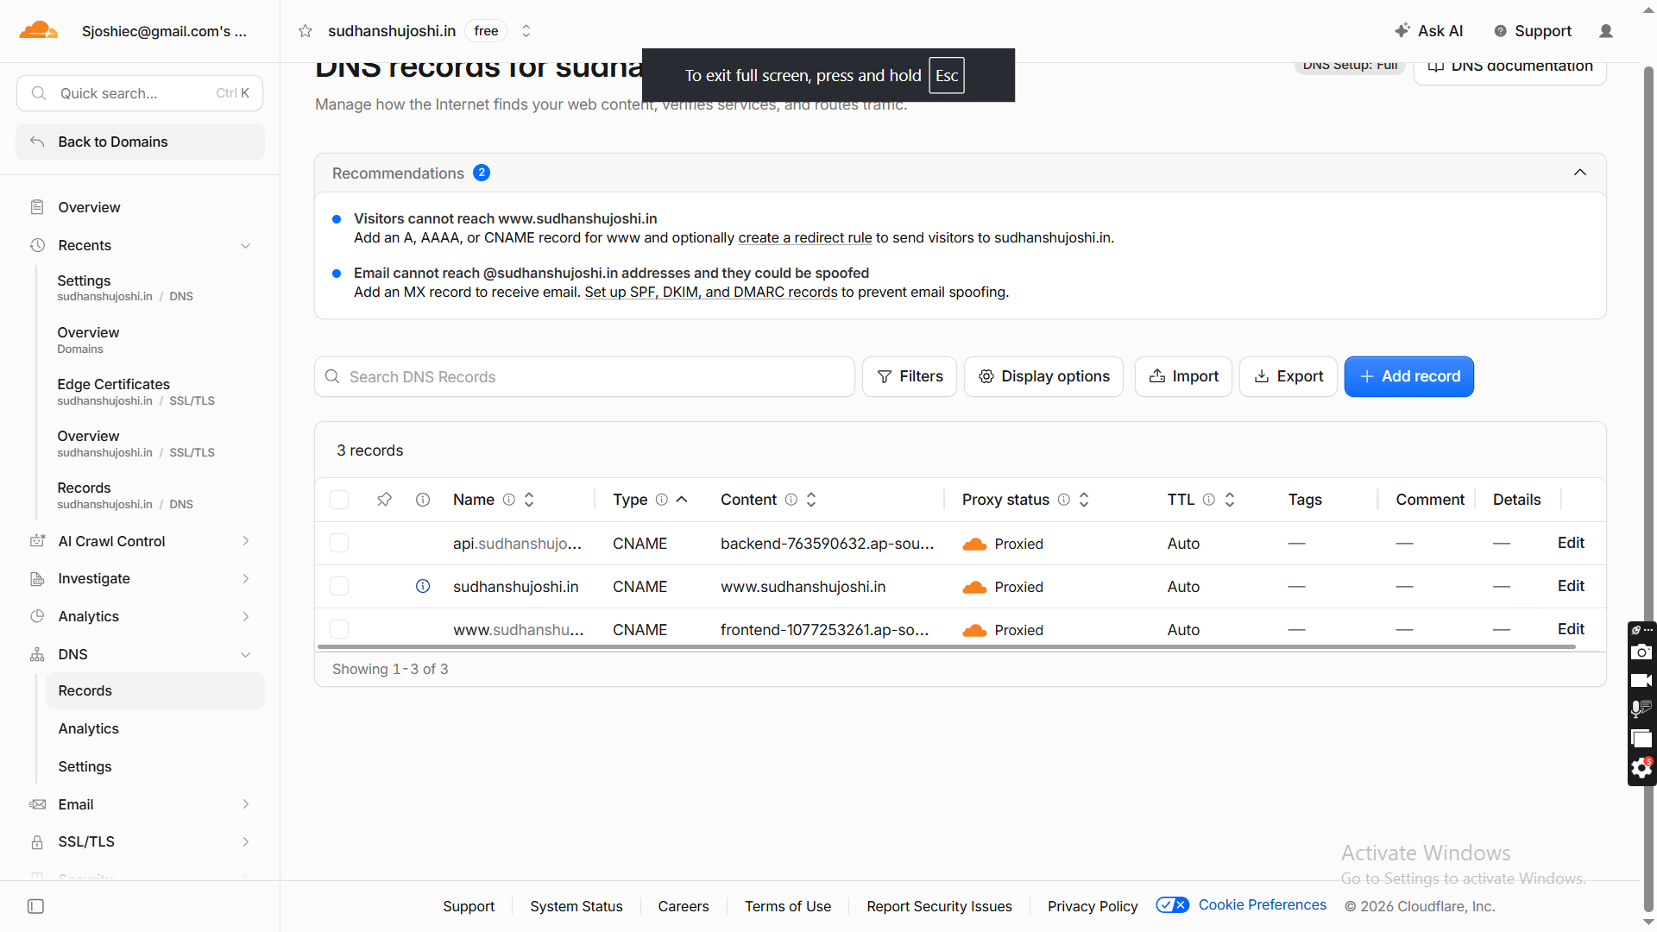
- Successfully tested backend CNAME resolution to ensure proper routing.
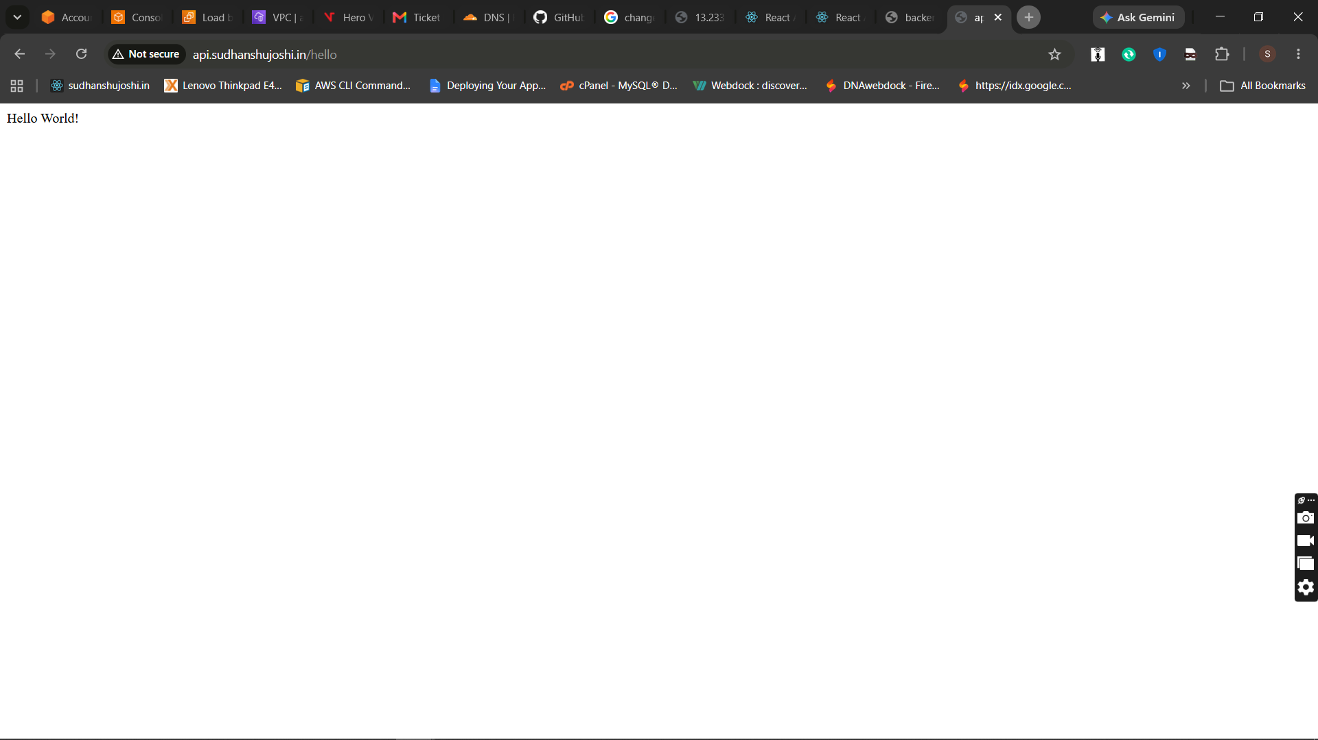
- Verified frontend accessibility through the custom domain with HTTPS enabled.
Created SSL using AWS Certificate Manager (ACM) *.sudhanshujoshi.in
applied HTTPS 443 listeners to both backend and frontend load balancer taget group ec2 http:80.

Verified secure HTTPS communication between frontend and backend APIs using the custom domain.
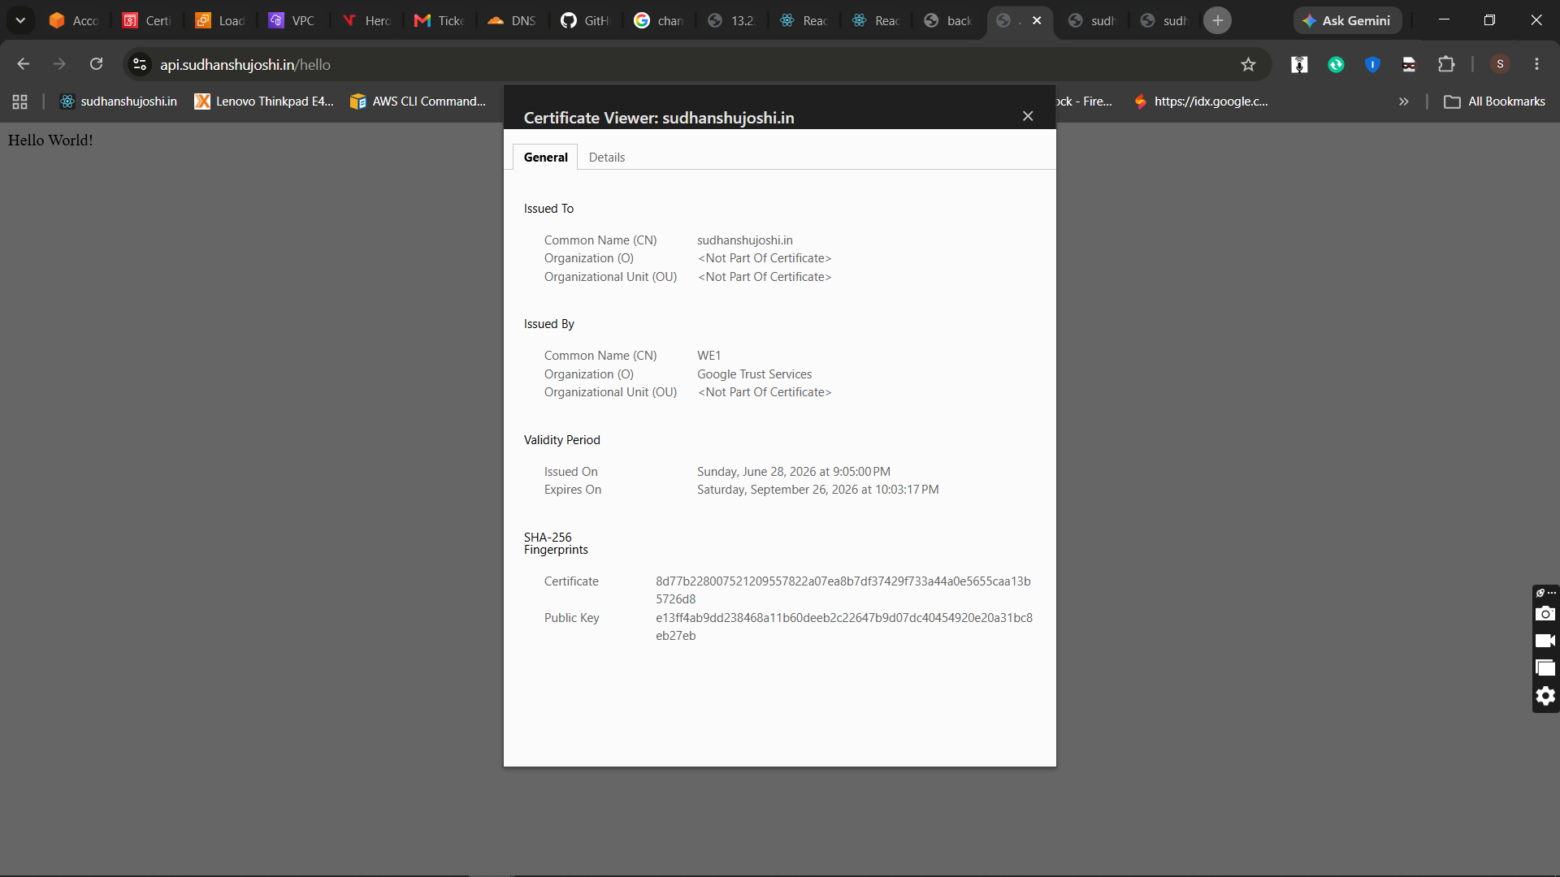
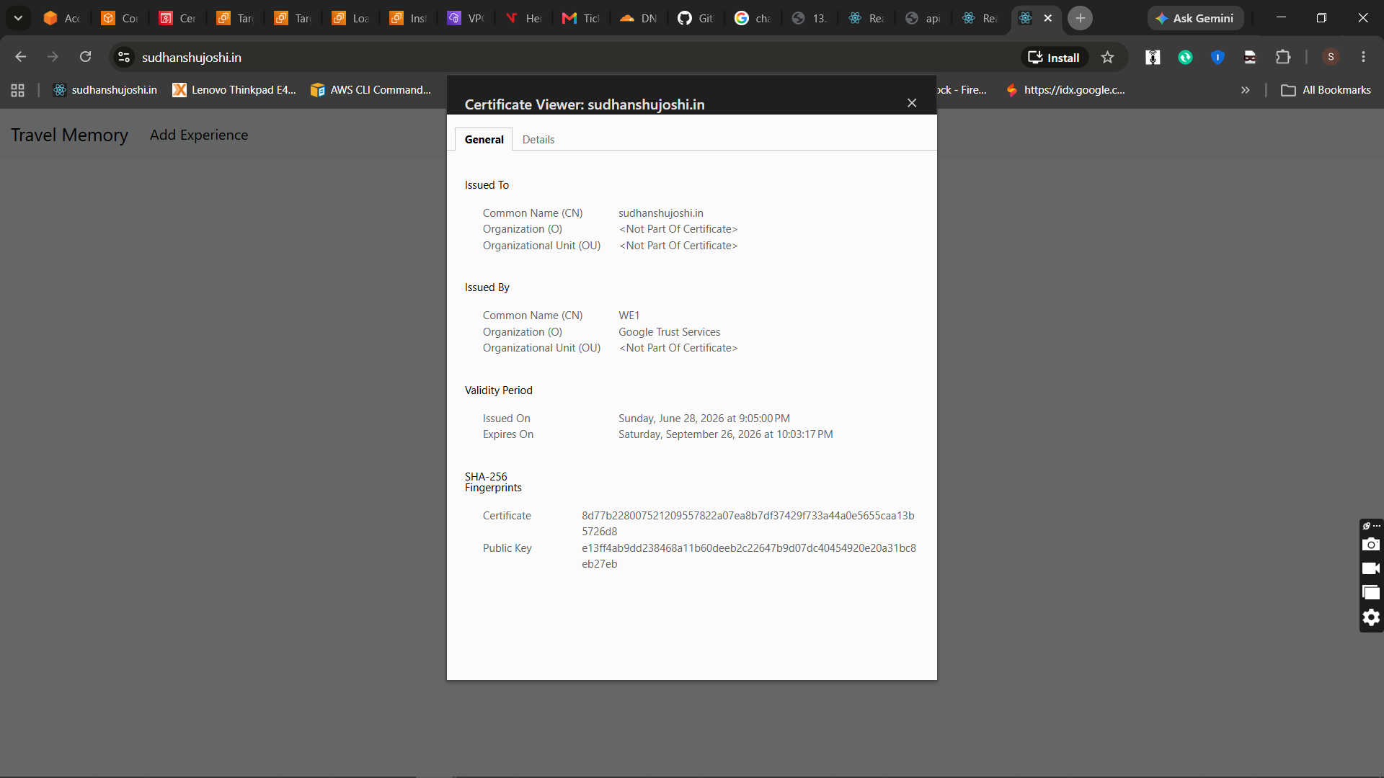
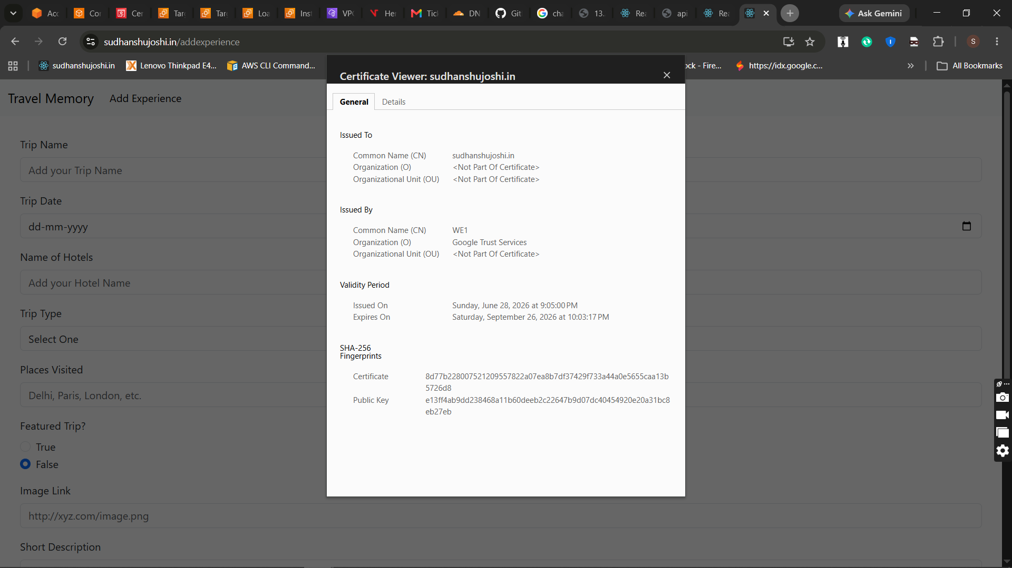
Conclusion
The Travel Memory application was successfully deployed on AWS using a secure and scalable architecture. The deployment included EC2 instances for hosting, MongoDB for database connectivity, PM2 for process management, Nginx as a reverse proxy, an Application Load Balancer for traffic distribution, and Cloudflare for DNS management and HTTPS support. The application was tested successfully, ensuring reliable performance, secure communication, and readiness for future scaling and production use.

